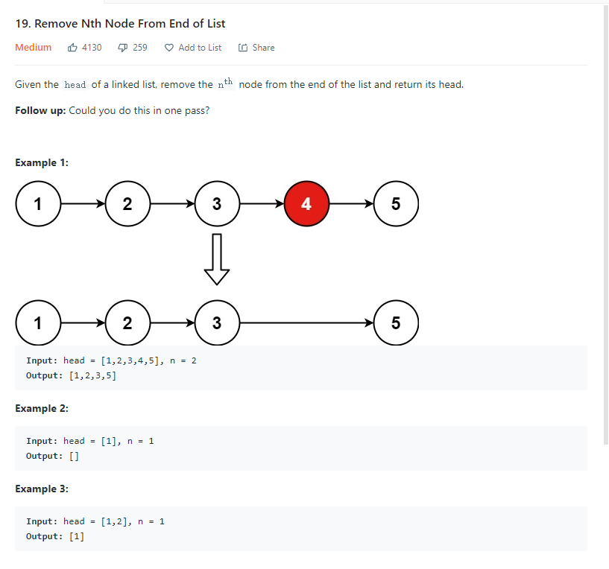

要求倒着数第n个去掉

如果能多次遍历就很简单，第一次用counter知道长度，第二次counter-n就行

一次遍历需要用到快慢指针

让快指针先跑，快慢指针间保持n的差距，一起移动，

那么当快指针到底变成Null的时候，慢指针正好指向要挪走的数

List Node可以先写一个dummy在Head前面，这样我们对head操作更方便

class Solution {

public ListNode removeNthFromEnd(ListNode head, int n) {

ListNode dummy = new ListNode(0);

dummy.next = head;

ListNode first = dummy;

ListNode second = dummy;

// Advances first pointer so that the gap between first and second is n nodes apart

for (int i = 0; i < n ; i++) {

first = first.next;

}

//移example1 为例，first会变成2，second还是dummy0,也就是他们始终差，两格

// Move first to the end, maintaining the gap

while (first.next != null) {

first = first.next;

second = second.next;

}//first停在5，second停在3

second.next = second.next.next;

return dummy.next;

}

}

}

}